**SPINE SIMULATION-UNREAL ENGINE**

**Goal:** Help surgeons locate pain source

* Create a patient-specific graphical model of lumbar spine.
* Simulate bending and twisting of the spine to look for the places where nerves could be pinched.

**Requirements:** 3D Slicer, Blender, Unreal Engine

**Steps:**

* Installed 3D Slicer software.
* Imported raw data into 3D Slicer and created a spine model.

* Exported the obj files in a new folder.
* Installed Blender software.
* Stacked the obj files together in blender.
* Now, got a spine model with single obj file.
* Imported the model in blender.

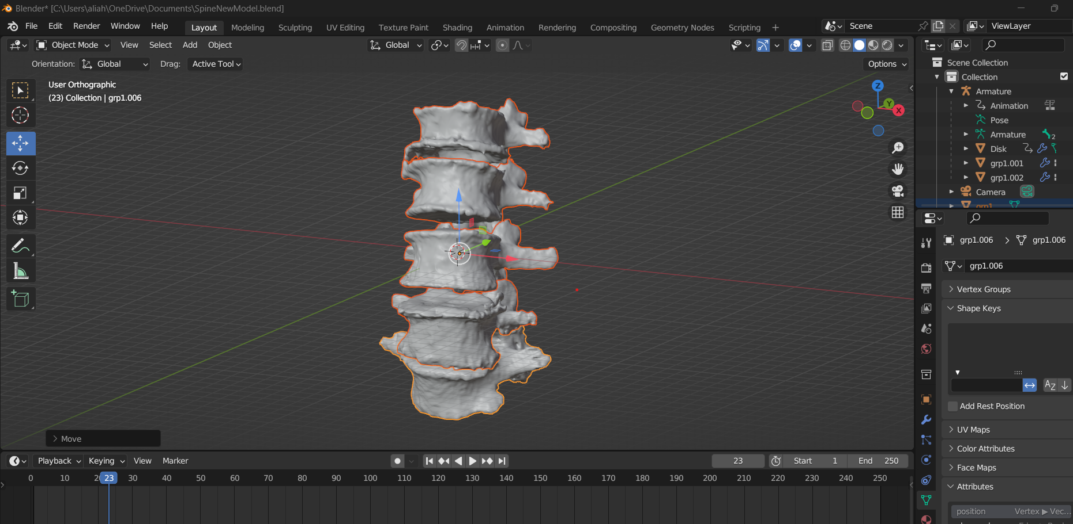

* Removed the extra vertebrae’s and created a disk in between the vertebrae’s and Created a armature(cone like structure) so the vertebrae’s can act as rig.

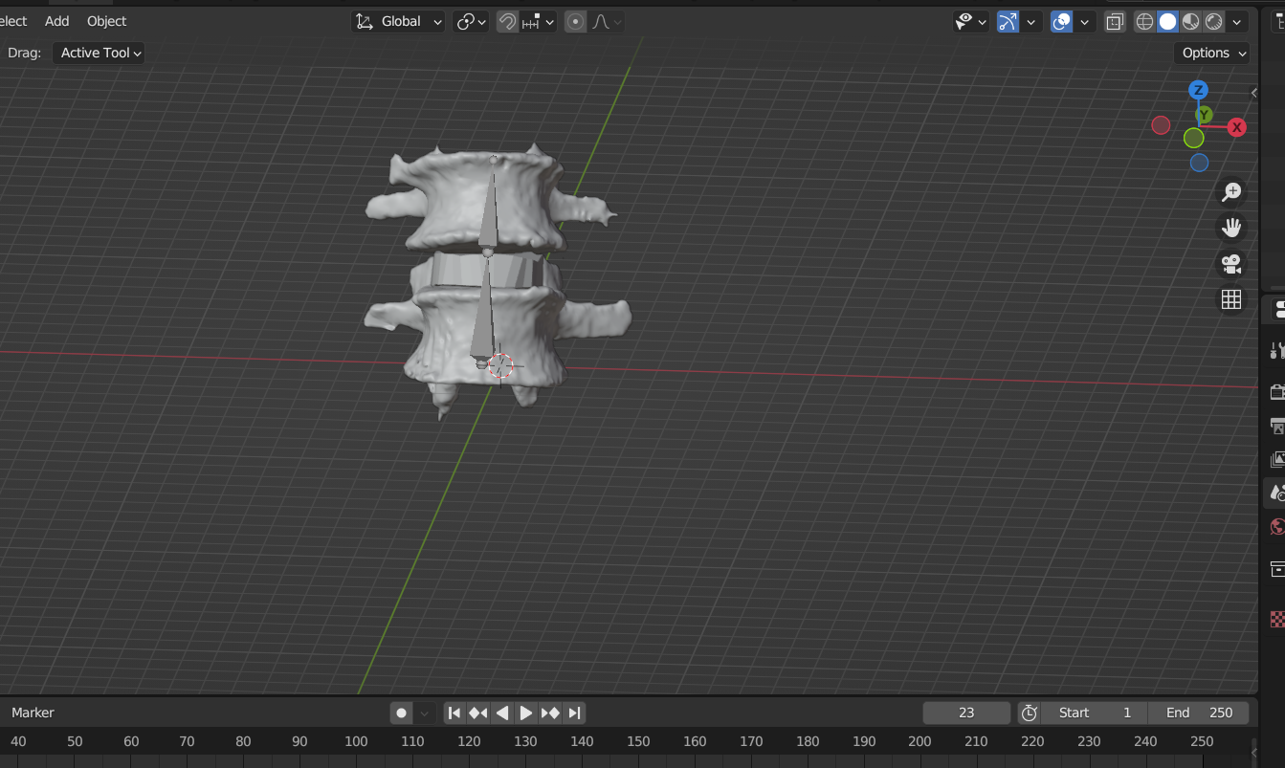

* Changed the material of vertebrae’s.

* Created animations of bending and twisting by adding keyframes on multiple intervals.

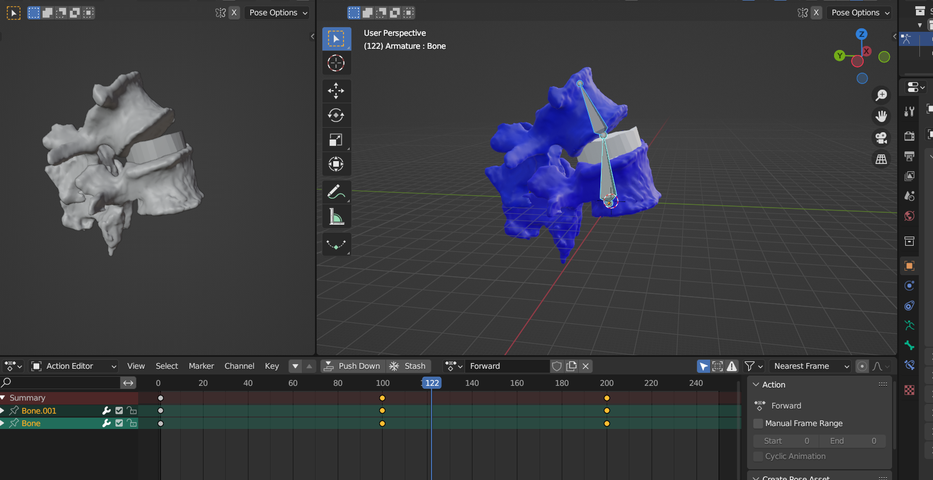

* Exported the model in the .fbx format so that we can import in unreal engine.

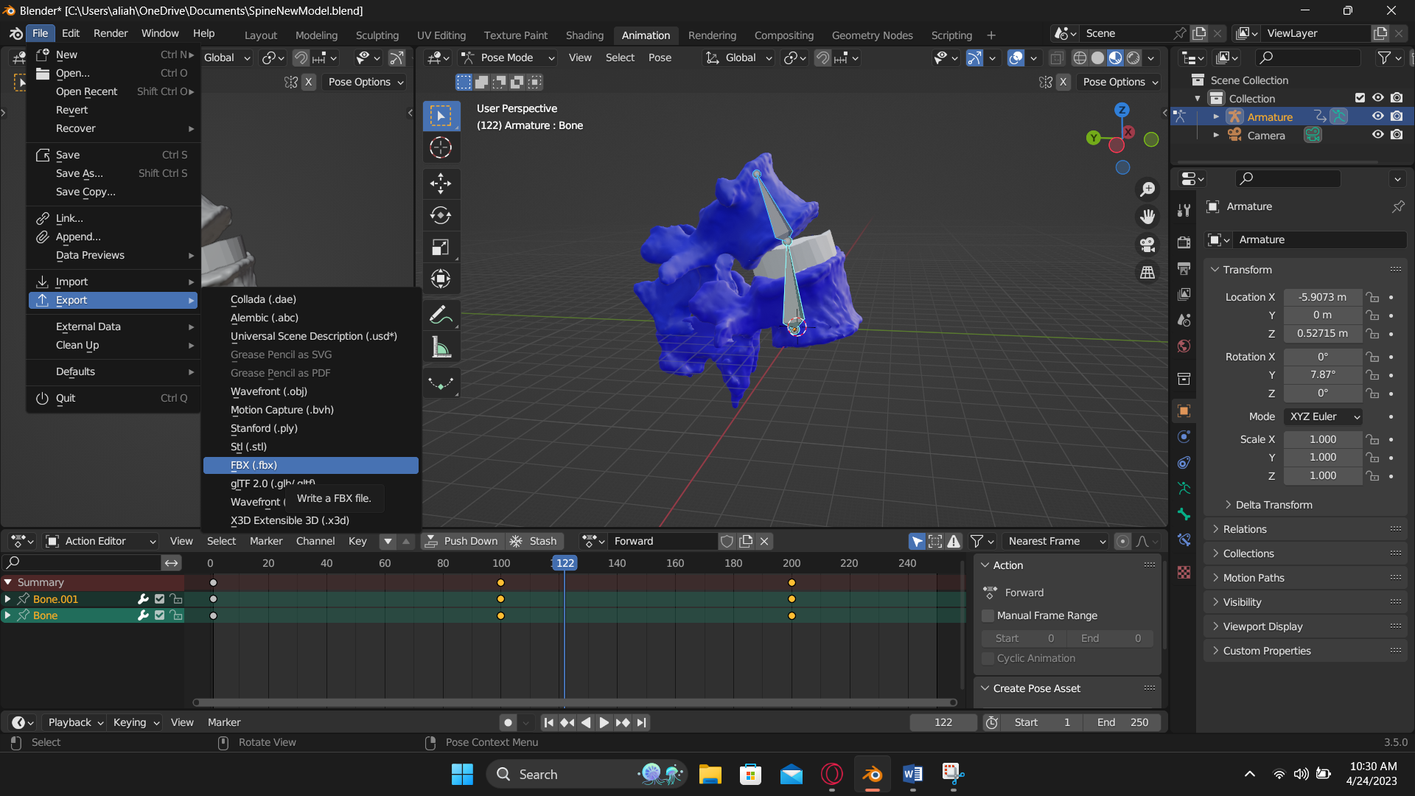

* Installed Unreal Engine.
* Created a new project and imported the .fbx file in unreal engine.

* In the blueprint of the Bone, we created the EventGraph and triggered the animation on some inputs.

* We set the bending and twisting angle, and when the bone exceeds that angle we can see the pinching.

